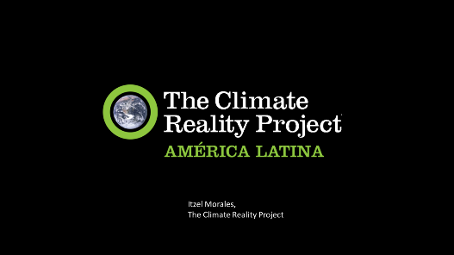
USFS – IP ISCC Alumni Webinar
Communicating Through the Climate Paradox
Presenter: Itzel Morales
3 August, 2020

Supplemental Resources

Burke, Susie. (2017). The Climate Change Empowerment Handbook: psychological strategies to tackle climate change, Australian psychological Society.
https://www.psychology.org.au/getmedia/88ee1716-2604-44ce-b87a-ca0408dfaa12/Climate-change-empowerment-handbook.pdf?utm_medium=PromoTile&utm_source=website

Dupar, Mairi. (2019). Communicating climate change: A practitioner's guide, Insights from Africa, Asia and Latin America. [Climate and Development Knowledge Network (CDKN)] (Information and case studies about tailoring climate communication to specific contexts.)
https://unfccc.int/sites/default/files/resource/Communicating%20climate%20change_Insights%20from%20CDKNs%20experience.pdf

Hendricks, Rose. (2017). Communicating climate challenge: Focus on the framing, not just the facts. (2017) [The Climate Reality Project] The article examines the paradox of science communication. (“Never have human societies known so much about mitigating the danger they faced but agreed so little about what they collectively know.")
https://www.climaterealityproject.org/blog/communicating-climate-change-focus-framing-not-just-facts

Leiserowitz, Anthony, et al., (2020). Climate Change in the American Mind
https://www.climatechangecommunication.org/wp-content/uploads/2020/05/climate-change-american-mind-april-2020b.pdf

Shanahan, Mike, et al. (2013). Climate Change in Africa: A guidebook for journalists.
https://unesdoc.unesco.org/ark:/48223/pf0000225451?posInSet=1&queryId=f5fa26d9-724c-49ff-a0f0-a0b82b6a7936

Shome, Debika, Marx, Sabine. (2009). (The Psychology of Climate Change Communication: a guide for scientists, Journalists, educators, political aides, and the interested public. [Center for research on environmental decisions (CRED).
http://guide.cred.columbia.edu/pdfs/CREDguide_full-res.pdf

UNESCO. (2020). Climate Change Disinformation Webinar Series. https://en.unesco.org/covid19/communicationinformationresponse/webinars

UNESCO. (2019). Changing minds, not the climate. UNESCO mobilizes to address the climate crisis [meeting document]. https://unesdoc.unesco.org/ark:/48223/pf0000370750.locale=en

